Getting AWS Cognito tokens
- Install and configure AWS CLI (access and secret keys are needed)
- Create a user in AWS Cognito or through app
- Get username from AWS Cognito console
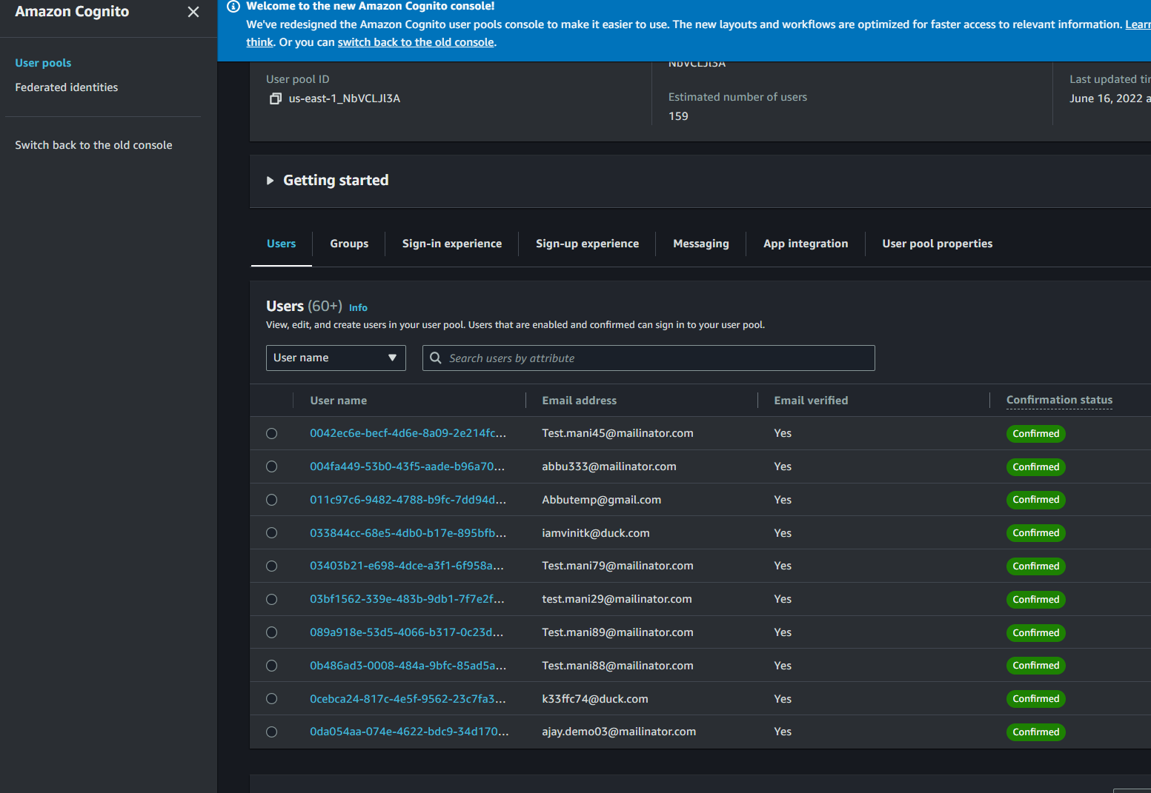
- Get user using the following command
aws cognito-idp admin-initiate-auth --user-pool-id us-east-1_NbVCLJl3A --client-id 49698a140ds3fa4bsi2p24qj26 --auth-flow ADMIN_NO_SRP_AUTH --auth-parameters USERNAME=ab8b2ec1-c1a5-4f97-846e-17e2339b8622,PASSWORD=ammu123456
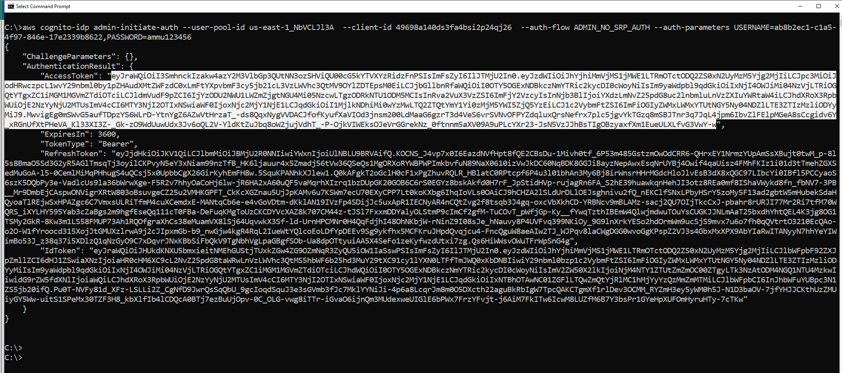
- Use following to reset password through CLI
aws cognito-idp admin-set-user-password --user-pool-id us-east-1_NbVCLJl3A --username ab8b2ec1-c1a5-4f97-846e-17e2339b8622 --password ammu123456 --permanent

- Get access token and ID token from the above
- In post man update header
